Computer Graphics Rendering of Seashells

David Clarke

MSc in Computer Science

Supervisor: Dr. Ela Claridge

School of Computer Science, University of Birmingham

22nd September 2003
Table of Contents
Abstract
(suggested length: half a page)

The Abstract should be a succinct and self-standing summary of the basis and achievements of the project. Be straightforward and factual and avoid vague statements, confusing details and "hype". Do not be tempted to use acronyms or jargon to keep within the half-page limit. Consider that search engines, librarians and non-computer scientists wishing to classify your dissertation rely on the abstract. You may if you wish provide a short list of keywords (2-6 is reasonable) at the end of the abstract.
Acknowledgements

Ela Claridge
Asim Farooq
The Inspection Team – Georgios Theodoropoulos, Antonio Diller
GameDev DirectX Forum
Introduction

In this section, you should describe the motivation for the project. Explain whatever background the reader will need in order to understand your contribution. Include a clear and detailed statement of the project aims. Describe the requirement that your software is fulfilling. Explain exactly what your software does; what input or data it requires, and what output or results it delivers, or how it interacts with the user. Concentrate on what your software does; the question of how it does it will be dealt with in later sections.
The introduction is the most important section of the document; everyone who reads your dissertation will read the introduction, and many will read only that section. You have to make it as inviting and compelling as you can. Think carefully about what you want to say, and in what order you should say it. As well as being the most important section, it's also the most difficult one to write, because it is hard to balance the requirements of giving adequate explanation without entering into too much detail.
For these reasons, you should write the abstract and introduction last. It is only when you've written the rest of the dissertation that you know what you have to introduce.
Conventionally, the last part of the introduction outlines the remainder of the dissertation, explaining what comes in each section.

Further background material. If your project is in a specialised area, it might be appropriate to provide more information than was given in your Introduction. Try to limit yourself just to what the reader needs to know to understand your contribution in the project. Put your work in the context of related existing work, commercial products, and research papers (if relevant).
Analysis and Specification. How you analysed the problem, including user requirements. Give an appropriate specification of the solution (note that you are not expected to produce a requirements specification to industrial standards).

The project proposal gives all the details required for this section. Put this in the appendix of the report.
Design. A high-level account of the structure of your software and how it works. What algorithms does it use? How do these compare with alternatives? What were the main design decisions you took, and their justifications?

The software comprises of two main components:

- The shell rendering display
- The shell rendering controls

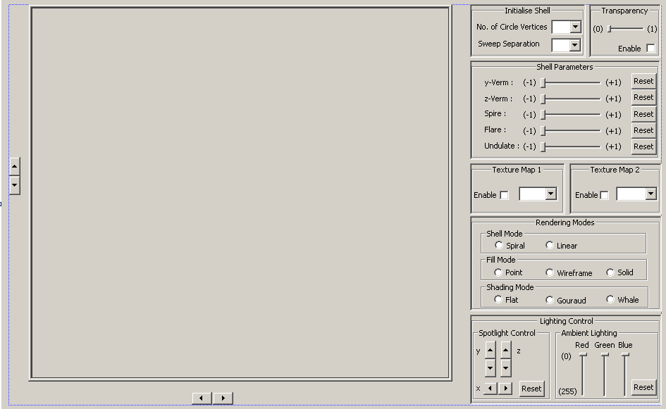
Shell rendering display
Shell rendering controls
Figure 1: Interface

In researching, a number of programming languages and graphics libraries were found to be available. I chose to use C++ and DirectX because they are the best-documented and up to date graphics programming software tools presently on the market.
Both the shell rendering display and rendering controls are programmed in C++. The controls form part of the user interface, whilst the display outputs the rendered shell. The user interface is formed from MFC (Microsoft foundation class) library components, whilst the rendering display is produced using the Microsoft DirectX9 library.
There are four main components to the program:

- The Custom Vertex object
- The Shell Vertices object
- The MFC components
- The DirectX (DirectInput and Direct3D) components

Initially, the shell rendering display was created as a stand-alone unit, as described in stage one of my project proposal. The rendered output was displayed in a basic window. The shells vertices and position was updated using a mixture of windows keyboard, DirectInput keyboard and mouse data. The response time of the program to DirectInput data was much better than windows input. DirectInput was thus used to alter some of the more reactive tasks such as:

- Shell mathematics updates
- Shell positional updates
- Spot light positional updates

The less responsive windows keyboard presses were much better designed to handle graphical mode state changes such as changes from:

- Points – Wire frame – Solid fill modes.
- Gouraud – Flat shading.

The rendering of the shell is described thus: When the program is running, it enters an infinite loop where messages (keyboard presses, mouse clicks etc) are processed and the render function is called.
Rendering of the shell occurs if the program is not processing messages. In the time the program is rendering, the:

- area of memory where the frame visuals are stored is cleared.
- colour of the objects to be displayed is initialized.
- scene lighting is initialized.
- position of the worlds objects are updates
- coordinates of the worlds objects are updated
- objects vertices are updated.
- objects are displayed.

One of the main design decisions I took anchored on the viability of creating an effective user interface in the available time. There were two main ways of creating a GUI using visual C++, use either MFC or Forms. The latter is the newest way of creating user interface components. However, MFC has better documented tutorials than Forms. The main problem apparent with GUI components was how could they be integrated successfully with DirectX9. Documentation about this particular problem was difficult to find. The best answer available at the time was Microsoft’s DirectX/MFC template. The DirectX9/MFC template is available in the software package Visual Studio after the DirectX9 software development kit is installed.

The only way I could see my rendering program working successfully with MFC was to create a new DirectX/MFC template derived program. Through trial and error I inserted my shell vertices code in place. The template provided the bare essentials i.e. the shell rendering display and an area where MFC GUI components could be placed. The functions available previously through keyboard via windows and DirectInput could now be made visible to the user via the interface. Using the Visual Studio resource window, templates of GUI components could successfully be ported to the DirectX/MFC template window. A message map was written for each component to link its action to the appropriate change in variable values. This simply meant writing a function for each GUI module then mapping it to that function. The function then simply read in the value and assigned the value to the appropriate variable.

- Mention sweeping
- Mention Helico spiral

Shell Surface Algorithm

The following algorithm was used to calculate the vertices that constituted the shell shape.

- Initialise the values of the variables in the underlying mathematical equations.
- Given the number of points that make up the shell spiral cross-section, calculate the aperture shape template.
- Given the number of spiral points and separation between points, use the mathematical equations to calculate the spiral path points.
- Take the aperture shape template; scale, rotate and translate to the next point along the spiral path.
- Store the vertices position.
- Repeat parts 4 and 5 for all the spiral points.

When the above algorithm has completed, vertices (points) need to be replicated and reordered so that they can be fed into the vertex buffer. When creating the vertex buffer a number of parameters need to be included:

- Number of vertices needed to be copied
- The data that each vertex holds i.e. positional, texture etc

To copy vertices data into the to the vertex buffer, it must be “locked” and told . The vertex buffer must be told in advance:

Implementation and testing. A detailed account of the implementation and testing of your software. Explain what data structures you used, and how the algorithms were implemented. What implementation decisions did you take, and why? There is no need to list every little function and procedure and explain its working in elaborate detail; use your judgement on what is appropriate to include.

Implementing the Shell Surface Algorithm

The shell vertices calculation was contained within one function present in the ShellVertices class. The majority of get and set methods within this class were used to change the parameters within that function. The rendered shell is based on the exponential spiral model.

x

z
θ
r

Figure

Choose initial values for the following constants:

θ₀ – The angle from which the spiral begins, in the case of this program assume to always be zero.
Δθ - Difference in angle between neighbouring vertices taken along the spiral.
λ – The rate at which the sweeping radius increases with each successive vertex along the spiral path.
R₀ – the initial length of the spiral radius
Z₀ – the initial depth of the spiral

θ_{(i+1)} = Δθ
r_{(i+1)} = r_{i} x λ
x_{(i+1)} = r_{(i+1)} cosθ_{(i+1)}
y_{(i+1)} = r_{(i+1)} sinθ_{(i+1)}
z_{(i+1)} = z_{i} x λ

It can be seen that the radius used to sweep the exponential spiral can be split into its respective x and y components. The z component is

The shell surface itself is made up of many vertices. Each vertex has a number of attributes associated with it including:

- Positional Coordinates
- Vertex Normal Coordinates
- Transparency
- Texture Coordinates

The positional and vertex normal coordinates are of most importance. The positional coordinates quantify the position of the vertex in 3D space. The vertex normal position specifies the direction in which the light should reflect off the object. In a world where there is a light source, vertex normals must be specified else the object would not be visible. Both the positional and vector normal coordinates are of a type D3DXVECTOR3, a 3D vector type inherited from DirectX. Due to the size and extensibility of the vertex, it is given its own class, CustomVertex.

The CustomVertices are collectively used in a class called ShellVertices. ShellVertices handles the calculation and storage of all CustomVertices. Within the ShellVertices class there is a function that calculates the shell vertices, which is ironically called calculateVertices. The algorithm used to calculate the sweep shape is specified below.
V2
V1
V0
V3
z
y
Radius of Cross-section
z
x

Figure: Example of how the sweep shape is constructed, specifying NOOFCIRCLEVERTICES = 4.

Given the radius of the initial cross-section is a constant. CIRCLE_R = C.
Iterate through the loop.
Within that loop calculate the angle at which the current circle vertex should be placed. Calculate the y and z coordinates of the circle vertex given the equations
CIRCLE_R*sin(angle) and CIRCLE_R*cos(angle) respectively. Save the vertex position coordinates in a D3DXVECTOR3 array of size NOOFCIRCLEVERTICES.
Exit loop when the iterator equals the NOOFCIRCLEVERTICES.
User interface. If the interface forms a substantial part of your project (e.g. an HCI project), you will wish to include quite a lot of detail and explanation. In other projects the interface may be less of an important focus.
Project management. How have you managed the writing of a substantial piece of software? Discuss the appropriateness of your methods in the light of your experience on the project.
Results. You may have produced experimental results or other kinds of results during the course of your project.
Appraisal. You should assess the success of your software. How does it compare with the original specification? How reliable is it? How have you tested it? Comment on its robustness (e.g., to unexpected data), performance (e.g., response times or processing times in different situations), etc.
Conclusions. Here you will summarise your achievements and also the deficiencies of your project. You can also say what you would or could have done, if you had had more time or if things had worked out differently. It is important to be completely honest about the deficiencies and inadequacies of your work, such as they are. Part of your aim is to demonstrate your ability to recognise problems that remain.
References and/or bibliography. List any books, articles, lecture notes, conference proceedings, manuals or other documents that you refer to in the dissertation and/or that were important in your work. Look in any published book for how to do this. Cite at least the authors, the title, the date and the publication details of each document.
Appendices. You may include other documents here, such as: the project proposal; a selection of experimental data; schedules; testing strategy; risk management plans; glossary; manual; etc. Don't include the source code as an appendix (submit it electronically instead; see below). Don't include voluminous appendices (these should also be submitted electronically).

